How to Set-up Gmail and Google

Calendar on your iPad
To get your new/existing school Google account onto your iPad's, you'll want to go to Settings > Mail or Calendar or Contacts.

1. Launch the Settings app from your Home screen.

2. Tap on Mail, Contacts, or Calendar.

3. Tap Accounts.

4. Tap on Add Account.

5. 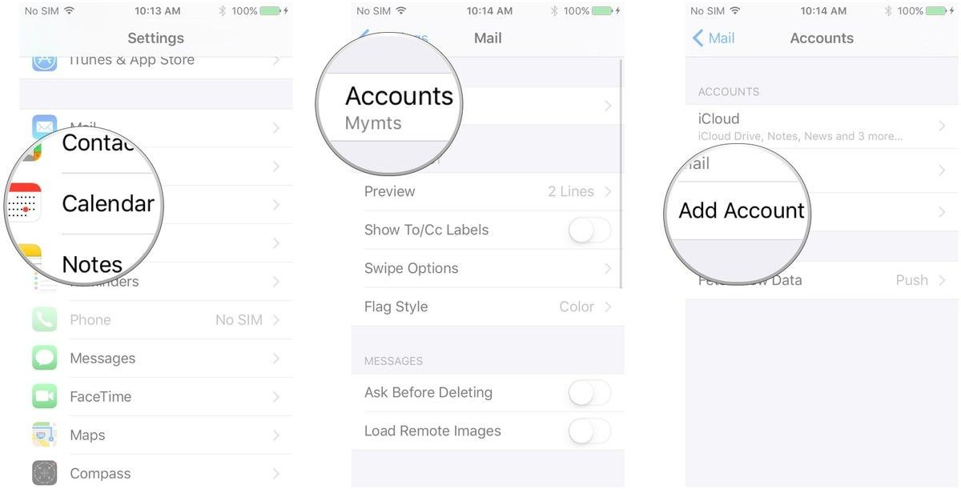

6. Tap on Google.

7. Enter your login information for your Google account (your Spellman email address and password) and tap

Next after each step.

8. Tap the switch next to each Google service you'd like to sync. If you have existing local mail, calendars, contacts, or notes, you'll have to either tap Keep on My Phone or Delete each time you enable a service.

9. Tap Save in the top right corner of your screen.

10. 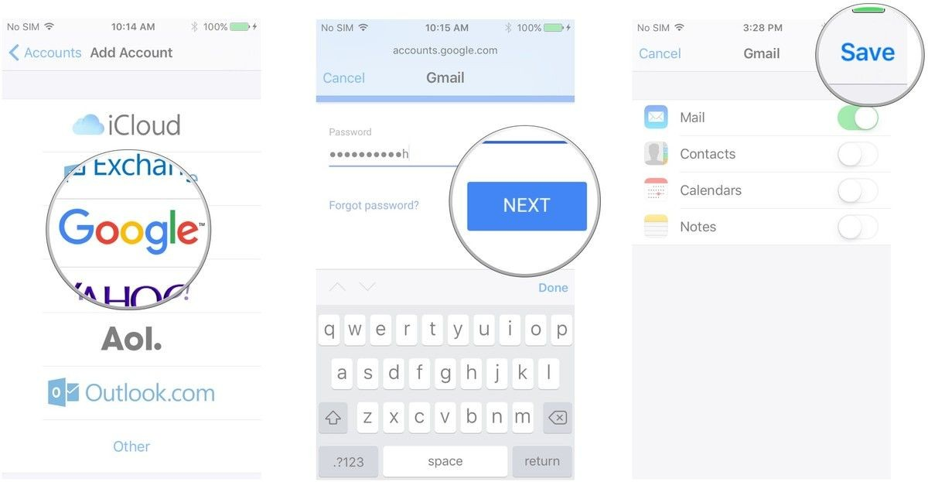

11. After you save your account, you can access your settings at any time by tapping the Gmail entry under the Accounts header. If you'd like to change
the description from "Gmail" to something more apt, tap the Account button, then tap the Description field.

12. You are done!!

